CHAPTER 3

A DIGITAL SHORELINE ANALYSIS SYSTEM (DSAS) APPLIED ON SANDY SHORELINE CHANGES IN DEER ISLAND, FL

Introduction

Coastal shoreline changes can occur due to multiple factors, including sea-level rise (SLR), anthropogenic human activity such as development, and hurricane intensity (Yu et al., 2011). The combination of these processes can influence erosion and accretion of shoreline areas. When shorelines change, the resilience of these geographic features may be compromised, resulting in cascading effects to species, their habitats, and ecosystems (Desantis et al., 2007). In Florida, the highest erosion rates have been localized around tidal inlets, and the most stable beaches are along the west coast characterized by low wave energy and beach nourishment, minimizing erosion (Morton et al., 2004). Florida also has low relief geomorphology, particularly along the west coast of Florida, and has been vulnerable to coastal erosion (Geselbracht et al., 2011).

Climate Change and SLR

In recent decades, the rate of SLR in many regions of the world has increased, most likely due to changing climate (Cahoon and Gunternspergen 2010, Mimura 2013). This acceleration in SLR and the observed impacts on coastal environments, including urban areas (Habel, 2020) and natural regions (Williams et al., 1999), is of increasing concern to property owners, municipalities, and natural resource managers (Kopp et al., 2019). The impacts of SLR globally are predicted to be profound to human communities and the natural environment (Brown et al., 2013, Curtis and Schneider, 2011).

One impact of SLR on both the built and natural environment is the increase in shoreline erosion that is predicted to occur. Erosion occurs when SLR shifts the high-water line (location on the shore where the water usually reaches high water) landward concerning the slope of the coastal area (Zhang et al., 2004).

In the Gulf of Mexico region, including the west coast of Florida, sand-dominated shorelines are common. Sandy shorelines are characterized by active environments and unstable substrate, consisting of sand, mixed sand, quartz, and/or silica (Brown & McLachlan, 2002). The unstable nature of unstable sand shorelines can create a harsh environment for biota, necessitating unique adaptations to this volatile environment, including (Brown & McLachlan, 2002). Sand shorelines accumulate sediment accretion by wave deposited particles of sand, mixed sand, quartz, or silica. These particles originate from a combination of inland erosion of material transported and deposited to coastal environments along rivers (Brown & McLachlan, 2002) and marine biogenic sources, including marine skeletons, sponge spicules, and shell fragments (McLachlan, 1990). Stable shorelines exist at an equilibrium of new material being deposited at the same rate material is eroded. However, when this equilibrium is disrupted or altered due to sediment transport or erosion, shoreline habitats can change rapidly. This exchange implies that seawater levels directly correlate with sandy beach erosion (Zhang et al., 2004).

Shoreline loss, as also need near our study site, has also been captured recently. In the mid-1960s, the US Army Corps of Engineers constructed spoil islands as part of the cross Florida barge canal project. These spoil islands consist of a straight line of islands perpendicular to the west Florida coast. Coastal changes have severely eroded or inundated these spoil islands, thus reducing habitat for animals (Vitale, 2019). Derrick Key is an example of a spoil island that was clearly visible in aerial photographs in 1982, and now the island is completely submerged (in 2016 photography). Significant shoreline differences are noticeably observed in the 34 years time between the imagery for this specific spoil island. Large scale efforts to analyze shoreline changes in Florida have been studied in the past (Yu et al., 2011; Sassaman et al., 2017; Houston, 2015; Li & Gong, 2016) however, it is interesting to note the possible effects of SLR on a smaller or regional scale, which might highlight processes which might be affecting larger-scale ecosystems and habitats.

Study Site

The Suwannee River estuary, Suwannee Sound, is a siliciclastic, sand-starved, and low-wave-energy system dominated by marshes that open towards the sea (Hine et al., 1988). Shoreline profiles in these systems can change over time due to low wave energy (Jackson et al., 2002), and storm events have also been observed to cause rapid change at specific locations (Goddard and Hine 1995).

The Suwannee River is the second largest river in Florida, spanning 370 km long, from southern Georgia to the west-central Florida coastline, and is considered a significant point source of sedimentation in the Suwannee Sound (Wright et al., 2005). The Suwannee River is a partially spring-fed system that also drains the coastal plain of Georgia and provides a restricted point source input of siliciclastic sediment, creating a small 20-kilometer delta (Wright et al., 2005). The surrounding coastal regions of the Suwannee River are otherwise known to be sediment starved. A significant sedimentology event has been shown that the Suwannee River has reworked ancestral fluvial sands and serves as a source for sandier marsh sediments (Wright et al., 2005). The Suwannee River has typically high discharge peaks between February and April and low discharge peaks between August and October (Purtlebaugh & Allen, 2010). The median annual river discharge measured of the Suwannee River at the USGS Wilcox site (latitude 29.58, longitude -82.93) is 2418 m^3/s with a minimum discharge of 998 m^3/s and a maximum discharge of 4971 m^3/s (USGS, 2021).

Suwannee Sound is encompassed by three rural Florida counties, Dixie, Levy, and Taylor (Figure 3-1, A and B). Currently, these counties are among the lowest human population density for coastal counties in Florida, but their populations are predicted to increase in future decades (Figure 3-1, C). Human development on coastlines may accelerate coastal erosion by creating a fixed position of the shoreline and stabilizing inlets, alters sediment transport (Finkl & Charlier, 2003). Increased human developments may also negatively impact coastal species diversity. Species biodiversity is threatened by the increase of urbanization and coastal environmental degradation (Finkl & Charlier, 2003). Czech et al. (2000) documented urbanization as the highest cause for species endangerment. For example, bird species, including Piping Plover (Charadrius melodus) and American oystercatcher ( Haematopus palliates), are known to forage and roost in areas of low human population, including Suwanee Sound (Thomas et al., 2002). Species biodiversity, both vegetative and animal, could be at risk due to increased urbanization along coastlines (McKinney, 2006) and accelerated shoreline erosion.

Recent Storm Events in Suwannee Sound Region

Suwannee Sound is considered a low energy environment because the nominal wave height is below the nominal high water line. High energy events, including tropic and winter storms, can increase wave and wind action in the region. Recent significant storms in the area include the “storm of the century” in March 1993, with wind speeds of > 15 m/s for 16 hours recorded at the Crystal River Power Plant roughly 100 km south of Suwannee Sound (Goodbred & Hine, 1993a). This weather event caused extensive damage to Waccasassa Bay (approximately 30 kilometers south of Suwanee Sound), including 3-meter water storm surges and storm-driven sediment deposits of up to 12 cm on coastal shoreline features up to 2 cm the marsh surface (Goodbred & Hine, 1993a). Hurricane Irma, a category 3 hurricane, made landfall near Marco Island and moved north along the Florida coastline, causing excessive rain and coastal flooding in the Suwannee Sound region. In 2016, Hurricane Hermine caused major flooding in Cedar Key, Florida, including the highest observed storm surge of >2.0-m (Berg, 2017). Tropical Storm ETA also made landfall in Cedar Key, a minor storm in 2020 (Lyons, 2020).

Within Suwannee Sound (Figure 3-3), prominent coastal features include numerous tidal creeks, intertidal and subtidal oyster bars, and small islands. One prominent island, Deer Island, is a privately owned uninhabited island approximately 13 kilometers north of Cedar Key, Florida. Historically, Native Americans intermittently inhabited Deer Island for thousands of years (USGS, 1955), and long-time Cedar Key residents report early Florida settlers were reported to live and camp on the island as well. The 1800 Florida census registered four people who identified this island as their home, and a small cabin is identified on a 1951 USGS Cedar Key Quadrangle map (USGS, 1955) of the region. At present, this island is located in the Big Bend Aquatic Seagrass Preserve and connects with the Lower Suwannee National Wildlife Refuge (http://www.beachrealtyfla.com/DeerIsland.htm). Deer Island is approximately 1,300 meters long from north to south and approximately 250 meters at its widest point (Mondes et al., 20212). Because of its historical and cultural significance to the region, Deer Island is commonly used by local residents as a geographic reference point for navigation and a recreation area. These same residents have also reported that Deer Island has changed in recent decades both in shape and area.

Objectives

This chapter will examine a portion of Suwannee Sound for evidence of shoreline change over time using various remotely sensed imagery. If change is evident, I will document this change and assess the rate and type of change to the observed shoreline features. Because Suwannee Sound is a region of low human population density and the immediate shoreline areas surrounding Suwannee Sound are state or federally protected lands, including the Lower Suwannee National Wildlife Refuge, shoreline change in this area is less likely to be influenced by significant factors observed elsewhere such as shoreline development. Any observed change in shoreline feature are more likely to come from other factors including SLR and storm events.

Materials and Methods

I cataloged available imagery of shoreline features for the region of Suwannee Sound. After compiling images from the National Agriculture Imagery Program (NAIP), a 25 year period of 1994 to 2019 was identified as having suitable images for use. This time series was divided into three time frames to locate an area of shoreline change where an identifiable factor may have triggered shoreline erosion or accretion. Two out of the three time frames split up the available imagery into equal years; however, there is no equal amount of imagery available covering each 12.5 years (e.g., 1994-2007, and 2010-2019). The last time frame includes all imagery to calculate how much total shoreline was lost or gained from 1994 to 2019.

Imagery Selection Process

Locating relatively cloud-free imagery for a specific location in Florida can be an exhaustive effort. Since our study location is unpopulated and contains no popular historic landmarks, historical aerial images are not frequently taken. To reduce the effort on locating usable imagery, Google Earth Pro was utilized. Google Earth Pro does not capture any of its imagery; however, it locates and uses imagery, in its finder view, comparatively cloud-free and high resolution. Google Earth Pro gave minimal metadata of the imagery, such as which agency captured the imagery and the date of the image, when using the time slider feature. Then USGS’s Earth Explorer (<https://earthexplorer.usgs.gov/>) was used to locate the actual imagery and its metadata. Upon inspection, it was determined that NAIP (National Agriculture Imagery Program) was the agency that acquired the most frequent and most detailed aerial imagery of our study site. The specifications for NAIP aerial imagery require a 1-meter ground sample distance with a horizontal accuracy that matches within six meters of photo-identifiable ground control points. These points are then used during imagery inspection. Contractually, NAIP attempts to comply with the specification that no more than 10% cloud cover be allowed in each aerial imagery tile. Aerial imagery is available as digital ortho quarter quad tiles (DOQQs) GeoTIFFs, which also correspond to the USGS topographic quadrangles (<https://www.fsa.usda.gov/programs-and-services/aerial-photography/imagery-programs/naip-imagery/>). It was also essential to select imagery close to the same time of the year, similar river discharge, and precipitation levels. All imagery chosen are between October through January. Table 3-1 includes all metadata associated with the imagery used in this analysis. Furthermore, observed weather and median river discharge are described, including the observed weather for the day of imagery collection and median river discharge measured. All selected images are available within the electronic repository for this thesis (https://github.com/melimore86/dsas_analysis).

National Agriculture Imagery Program employed sensor types with three-band imagery categorized as RGB (red, green, blue) until 2007. After 2007, four-band color infrared imagery was collected and categorized as CIR/CNIR (red, green, blue, and infrared). Four band imagery is multispectral, which means the sensors can collect information from several parts of the electromagnetic spectrum. To specify a natural color display, the GIS software settings should be band 1 set to red, band 2 set to green, and band 3 set to blue. Table 3-2 includes the sensor type associated with each image. Our November 2007 image is the first image in our series, which uses color infrared (CIR/CNIR). Using CIR/CNIR imagery allows the user to view the imagery in a false-color for NDVI (Normalized Difference Vegetation Index) analysis was not important in my assessment. Vegetation can be seen on Deer Island, but it is unnecessary for our DSAS analysis because the island vegetation is distinct and not integrated into the sandy shoreline. There is a clear and distinct separation between sand and vegetation. Additionally, the DSAS user manual does not have any recommendations for using true-color image composites. What was important is to account for differences in tidal height.

Digital Shoreline Analysis System (DSAS)

The DSAS is a GIS-based system created and maintained by United States Geological Survey (USGS). For this analysis, the DSAS ArcMap© extension was used. The DSAS extension casts transects along the baselines (starting point for transects) and measures the gaps between the shoreline positions during defined years. The user constructs baselines, and this analysis was created using the Buffer tool in ArcMap©. These shoreline positions provide the necessary data needed to calculate their shifts. The DSAS analysis generates transects perpendicular to the reference user-created baseline (Figure 3-4). The analysis explains that an intersection point is a cross between the casted transect and the shoreline boundary position for each specified year. The DSAS analysis then uses the distance in meters to conduct various calculations, which were previously described. Using the distance between transects, the DSAS can generate forecasted transects for10- and/or 20-year projections.

The DSAS calculations require an operational workflow to gather and create the necessary components. The components needed are shoreline baselines, other shorelines of interest (varying in different periods), DSAS transects (which are cast some the baseline and intersect the additional shorelines positions), measurement distances, measurement points, and shoreline uncertainty. All objects used in the DSAS are stored in an ArcMap© Personal Geodatabase, as per USGS requirements for this analysis. The DSAS operational workflow includes the following steps: (1) Set default parameters and fields to the created shoreline and baseline layers, transects, shoreline calculations, metadata, and file output locations; (2) Cast transects and select their maximum search distance, transect spacing, and smoothing distance; (3) Calculate change statistics such as confidence intervals, shoreline intersection threshold, rate of output display, and summary report; (4) Create data visualization for LRR and NSM; and (5) Beta Shoreline Forecasting for a 10 and/or 20-year prediction. One of each type of change metric (“Digital Shoreline Analysis System (DSAS) Version 5.0 User Guide.”, 2021) was used in this analysis, an LRR (Linear Regression Rate) for statistical analysis and the Net Shoreline Movement (NSM) calculation for the distance measurement.

Linear Regression Rate (LRR)

An LRR can be ascertained by fitting a least-squares regression line to all points for every shoreline in a transect. The regression line is positioned so that the sum of the squared residuals is minimized. The linear regression rate is the slope of the line. The LRR calculation can be used regardless of accuracy or trends. The LRR calculation is purely computational, and the results are based on accepted statistical notions. This method may be susceptible to outlier effects and tends to underestimate the rate of change compared to other statistics used using DSAS (e.g., End Point Rate (EPR)).

Net Shoreline Movement (NSM)

In contrast, NSM calculations only require the baseline position shoreline and the last shoreline position to make its computations (two shorelines). The NSM measures the distance between the oldest shoreline (e.g., 2019) and the youngest shoreline (e.g., 1994) for each casted transect measured in meters. The justification for using NSM statistics is to know the total measurement distance of erosion or accretion. Knowing this may have high biological significance since this fine-scale analysis has not been conducted in this study area. The DSAS default setting of 90% confidence interval was used to calculate NSM measurement.

Beta Shoreline Forecasting

The latest version of DSAS (v5.0) has an option available to calculate shoreline forecasts 1- or 20 years into the future. These calculations are based on historical shoreline position data. This calculation uses the Kalman filter (Kalman, 1960) to join shoreline positions with model-derived positions to predict a future shoreline position (Long and Plant 2012). The Kalman filter methodology initialized with the linear regression rate calculated by DSAS. Using the linear regression rate, it then estimates the shoreline position and rate of every 10th of a year. It also estimates the positional uncertainty at each time step. This methodology assumes that the linear rate of regression from the shoreline positions analyzed will be a good approximation for the position of future shorelines, where this assumption may not always be true or valid. It is best to display the results of this analysis with uncertainty.

DSAS Parameters and Selections

Selected NAIP Geotiff aerial imagery were in the Universal Transverse Mercator (UTM) coordinate system, Zone 17 North, and in the 1983 North American Datum (NAD83) (Table 3-1). Using ESRI’s ArcCatalog© and ArcMap©, separate shapefiles for each aerial image’s shoreline were created, traced, and digitized. The scale used to digitize was 1:3,000, and an MWL was discerned by looking at the whitest and brightest part of the shoreline that was not influenced by the dark ocean color. Shorelines were then merged into a new single shapefile using the ArcMap© Merge tool. The baseline selected can be found on the east side of Deer Island and is entirely inland. Both a baseline shapefile and merged shoreline shapefile are required for DSAS calculations (Figure 3-5, Inputs).

After I selected and pre-processed NAIP imagery, the DSAS analyses were completed using the following parameter specifications:

(1) 100 m buffer around the merged shoreline shapefile

(2) the east side of the buffer was used as the baseline (transects from the baseline will be cast from east to west)

(3) transects were spaced at 20-m intervals; the minimum transect spacing allowed by DSAS based on the small size of the study site

(4) 2000-m search for suitable shorelines was done adjacent to the transect; search distance looked for shorelines 2000 meters away from the baseline

(5) a smoothing distance of 500-m was specified; a smoothing distance is a user-specified smoothing value that can facilitate an orthogonal transect intersect by preventing transects from intersecting with one another when there is a curve in the baseline, and the larger the smoothing distance, the more likely to produce uniform transect orientations, which is recommended for smaller shorelines

Results

The results indicate that there have been more erosional events in all time periods. The calculations for the shoreline analysis are displayed in a colorblind color ramp. The LRR color ramp displays rates of change in m/yr, and the NSM color ramp displays the distance of measurements in meters. The DSAS calculations follow the standard that a negative rate implies erosion and a positive rate implies accretion. Results for all study periods conclude a pattern of consistent erosion and some events of accretion.

Imagery Observation

By overlaying NAIP aerial photographs, in the same scale (1:3,000) and projection (NAD 1983 UTM, Zone 17N) and similar environmental conditions (Table 3-1) from 1994 and 2019 demonstrates changes in Deer Island shoreline features which suggest erosion over this time period (Figure 3-6 A, B). For example, contrasting the 1994 and 2019 imagery suggests that the southwestern inlet has a larger open mouth to the sea than the 1994 imagery. This suggests that this feature has expanded over time, possibly due to erosion. The northeastern shoreline of Deer Island also has an outcropping that looks round and full in 1994 imagery but has changed shape to be pointy and thin in 2019 imagery. This change also suggests erosion. Still, even looking at aerial evidence, it does appear that there are most instances of erosion than accretion.

Shoreline Analysis for Years 1994-2007

The LRR analyses for the years 1994-2007 found years and transects of both erosion and accretion (Figure 3-7, A). The most common values among transects were erosional rates of about -2.0 to -1.0 m/yr (about 30% of all transects calculated), with some transects within years estimated to have lost between -5.0 to -3.0 m /yr (Figure 3-8, A). For transects within a year where accretion was observed, accretion rates of -0.5 to 0.5 m/yr were estimated. Overall, erosion was estimated to have occurred in 74.4% of transects, and accretion was estimated to have occurred in 25.6% of transects measured between 1994-2007.

The NSM results also demonstrate years of erosion and accretion (Figure 3-7, B). The highest erosion distance measurements range from -70.5 to -35.9 meters, and the maximum accretion distance measurements range from 4.3 to 6.4 meters (Figure 3-8, B). The most frequent NSM measurement range is -10.0 to 2.2 meters accounting for 29.3% of all transects calculated (Figure 3-8, B). The least frequent NSM measurement range is the accretional distance between 4.3 to 6.4 meters accounting for 1.2% of all transects calculated (Figure 3-8, B).

Overall, both methods suggest that between 1994 and 2007, Deer Island changed in the area due to erosional processes, with the highest erosion rates near the north and south end of the shoreline. Both methods also suggest that the most frequently calculated rate/distance is the rates/distance with intermediate erosion.

Shoreline Analysis for Years 2010-2019

The LRR analyses for the years 2010-2019 found years and transects of both erosion and accretion (Figure 3-9, A). The most common values among transects were erosional rates of about -0.5 to 0.5 m/yr (about 28% of all transects calculated), with some transects within years estimated to have lost between -4.0 to -3.0 m /yr (Figure 3-9, A). For transects within a year where accretion was observed, accretion rates of 1.0 to 2.0 m/yr were estimated (1.2% of all transects calculated). Overall, erosion was estimated to have occurred in 47.6% of transects, and accretion was estimated to have occurred in 52.4% of transects measured between 2010-2019.

The NSM results also demonstrate years of erosion and accretion (Figure 3-9, B). The highest erosion distance measurements range from -41.8 to -20.1 meters, and the maximum accretion distance measurements range from 8.7 to 9.9 meters (Figure 3-10, B). The most frequent NSM measurement range is -6.7 to 2.9 meters accounting for 25.6% of all transects calculated (Figure 3-10, B). The least frequent NSM measurement range is the accretional distance between 5.8 to 8.7 meters accounting for 4.9% of all transects calculated (Figure 3-10, B).

Overall, both methods suggest that between 2010 and 2019, Deer Island mostly changed in the area due to erosional processes with some accretional instances. Both methods also suggest that the most frequently calculated rate/distance is the rates/distance that encompass both erosion and accretion.

Shoreline Analysis for Years 1994-2019

The erosion LRR rates (Figure 3-12, A) in this analysis range from the highest erosional rate of -4.0 to -3.0 (m/yr) to the highest accretional rate range from 3.0 to 4.0 (m/yr). The most frequent LRR rate range is -2.0 to -1.0 (m/yr) accounting for 39% of all transects calculated (n=82). The least frequent LRR rate range is the accretion rates greater than 1.0 (m/yr), accounting for 0% of all transects calculated. For the NSM calculations (Figure 3-12, B), the highest erosion distance measurements range from -91.8 to -68.5 meters accounting for all transects calculated. The NSM maximum accretion distance measurements range from 10.5 to 11 meters, accounting for 1.2% of all transects. The most frequent NSM distance measurement range is -45.7 to -22.9 meters accounting for 25.6% of all transects calculated. The largest erosion measurement distance is seen at the north end of Deer Island, while the middle has some areas of accretion and less erosion. However, the south end of Deer Island has some sharp peaks of erosion, however not as high as the north end.

Table 3-3 concludes the DSAS NSM results calculated 81.70% of all transects for this time period were a negative distance. Only 18.29% of the transect resulted in a positive distance. The average distance calculated for each transect is -29.1 meters (taking into account positive and negative transects). The average of all negative distances is -36.83 meters. The maximum negative distance measured is -91.71 meters, while the maximum positive distance calculated is 10.91 meters.

Table 3-4 concludes the DSAS LRR calculations for the years 1994 to 2019. The average LRR rate calculated is -0.95 m/yr. The percent of all transects that are erosional is 76.83% (n= 63). The maximum value of erosion calculated is -3.32 m/yr, while the maximum value for accretion is 0.62 m/yr. The average of all erosional rates is -1.33 m/yr. The percent of transects with statistically significant erosion is 69.51%, while the percent of all transects with statistically significant accretion is 10.98%.

Beta Shoreline Forecasting Analysis for 10 and 20-Year Prediction

The 10-year prediction (Figure 3-13, A) demonstrates the potential of uniformity of erosion, particularly in the center and south end of Deer Island. The north end of Deer Island has an area south of the shoreline bulge that is projected to be eroded by the 10-year prediction. The 20-year prediction (Figure 3-13, B) is very similar to the 10-year prediction model, but with more drastic erosion in the north and south. A summary of the 10- and 20- year shoreline predictions suggest that erosion may occur on the north and south ends of the western shoreline of Deer Island, with some accretion located around the center of the island.

Discussion

I found that Deer Island shoreline features have eroded over two periods of time, both 1994-2007 and 2010-2019. My results also suggest that the number of transects examined for change on Deer Island had a higher number of transects demonstrating erosional in 1994-2007 than in 2010-2019. These differences may be a function of environmental factors, including storms, that likely influence change in shoreline features. As an example, the first imagery (1994) is taken one year after a severe winter storm (March 1993) that is known to have caused considerable changes in shoreline features elsewhere in the Big Bend region (Goodbred & Hine, 1993). It is possible that the 1993 storm contributed to several years of erosional along Deer Island due to destabilizing shoreline features from the storm.

The observed overall net loss of Deer Island shoreline could result in loss of habitat used by wildlife resources, including shorebirds. Vitale et al. (2020) documented erosion and shoreline retreat of islands used as nesting habitats by American Oystercatchers, including islands in the Cedar Keys region. Because Oystercatchers demonstrate high site fidelity and long-lives, Vitale et al. (2020) suggest that the loss of these islands may create a type of ecological trap where birds return to these islands only to have the nests destroyed due to eroded shoreline areas and increased vulnerability to inundation. Many other species depend on shorelines for food, nesting, and shelter (O'Connell et al., 2005). Shorebirds rely on shorelines for feeding habitats during migration in the winter months. Habitat loss, due to erosion, limits the availability of food and resources for these shorebirds, possibly resulting in increased competition. This increased competition may exclude individuals from a foraging site, increase mortality rates for these excluded shorebirds, and ultimately lead to limitations in numbers (Galbraith et al., 2005).

It is interesting to note that although the overall shoreline experienced erosion, evidence accretion might have occurred in the middle of the shoreline during the entire time period analyzed (Table 3-3). During this time period, the maximum positive distance gained was 10.91 meters occurring around the central shoreline on transect 44 (Table 3-3). Accretion for our study site may come from extreme meteorological events since a scant supply of sand is dispersed by the Suwannee River (Goodbred et al., 1998). However, it is unclear how much accretion can occur with the perpetuation of sea-level rise consistently stressing the sandy shoreline substrate. Florida can provide beach nourishment to areas where erosion is evident. Currently, there is no schedule to provide beach nourishment to our study site.

During this analysis, the primary source of error arises with the missing imagery years 2007- 2008 and 2011- 2012. If those missing years were available for analysis, it would provide a closer interpretation of the true erosion differences between the two 12 to 13-year time periods. Since our study site is uninhabited, remote, and not a tourist destination, it is not surprising to see that NAIP is not contracted to fly over this area every year. Another source for possible errors in the individual digitization of each shoreline due to user errors. Since the available imagery was used for digitizing the years’ shoreline, the digitization of each shoreline may differ from user to user. In this study, only one person digitized each shoreline to reduce this error. The resolution of each image was at least 1-meter resolution, which may be considered “high” resolution compared to 30-meter resolution from Landsat 7 and 8 (Fisher et al., 2018), where Landsat imagery may also be used for analysis. The higher the resolution is, the more likely the digitized shorelines are accurate.

The prediction models are based on a linear regression rate calculated by DSAS using a Kalman filter (Kalman, 1960). The Kalman filter conducts an analysis to minimize the error between the observed and modeled shoreline position to develop the forecast where the rate and uncertainties are considered (Long & Plant, 2012). Our prediction models project that more shoreline erosion is expected (Figure 3-12). This model predicts that shoreline erosion is expected to continue in future years based on observed erosion patterns. This prediction assumes that whatever mechanisms driving the observed shoreline loss (SLR, erosion from storm events) are likely to continue in the future. Under various climate change scenarios, storm events are predicted to increase in severity and possibly frequency (Knutson et al., 2020), altering the rate of erosion.

Sea level rise may be the dominant feature driving changes in shoreline features along Deer Island. While erosion and accretion are indeed occurring, sea level has been monitored in Cedar Key for more than 100 years (NOAA station 8727520, https://tidesandcurrents.noaa.gov/sltrends/sltrends_station.shtml?id=8727520) and the long-term sea-level rise is about 2.23 mm/yr. This rate has shown an increase since 2010 (https://tidesandcurrents.noaa.gov/sltrends/sltrends_station.shtml?id=8727520), and an increasing rate of SLR would likely lead to an increased rate of shoreline inundation and loss.

This study has revealed brief historical trends of coastal evolution along an undeveloped sandy shoreline. The shoreline statistics revealed greater meters of erosion during the first-time frame 1994-2007, possibly due to a significant hurricane impact. Storm and storm clusters may significantly impact barrier island morphology in this area with direct stormwind and tide impacts along with changes to wave energy. Changes in the frequency of storms may contribute to numerous changes to the low energy waves described in our study site. Long-term sea-level rise and sediment supply are considered major factors that stimulate shoreline erosion and accretion (Sankar et al., 2018). This research has demonstrated that sandy shorelines in this area may be susceptible to more erosion than accretion due to the factors mentioned, which may ultimately lead to multidecadal shoreline loss.

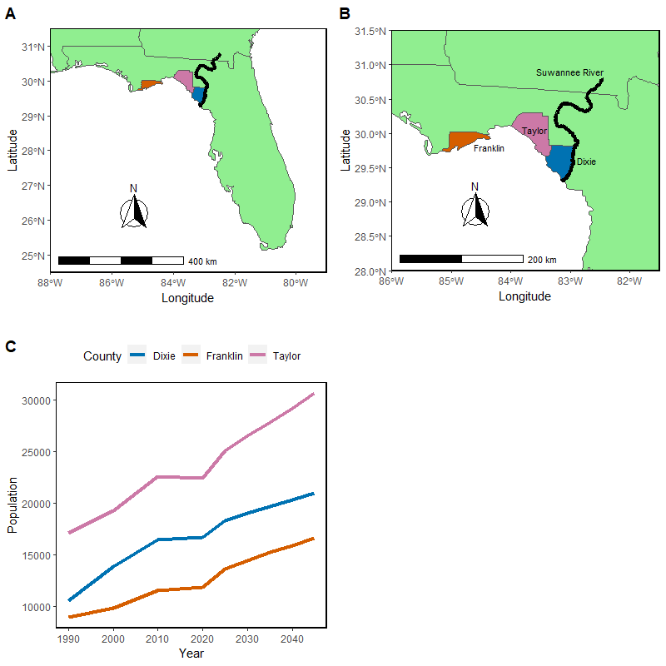

Figure 3-1. A) Map of Florida with Dixie, Franklin and Taylor counties identified along the Suwannee River; B) Zoomed in map of study area with Dixie, Franklin and Taylor counties identified along the Suwannee River; C) Projection human population data for Dixie, Franklin and Taylor counties 1990-2045 (Bureau of Economic and Business Research, 2021)

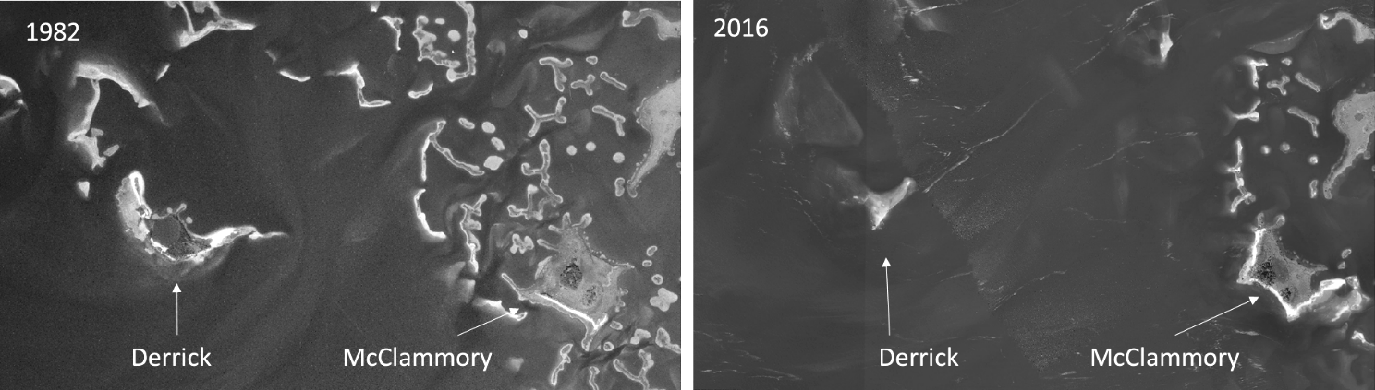

Figure 3-2. Island degradation of Derrick Key in the Cedar Keys, Florida from 1982 (left) to 2016 (right), (Vitale, 2019).

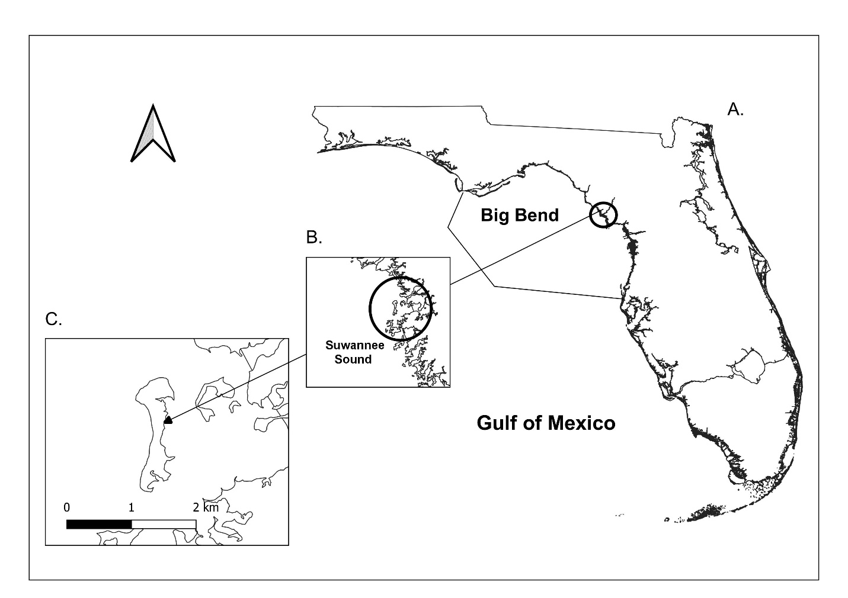

Figure 3-3. Location of Deer Island, Florida. A) Map of the entire state of Florida; B) Zoomed in study site; C) Zoomed into map scale of 0.03 to Deer Island with a scale bar in kilometers. Shoreline shapefile downloaded at my.fwc.com, (Original source map scale 1: 2,000,000 Scale, and digitized in 2017).

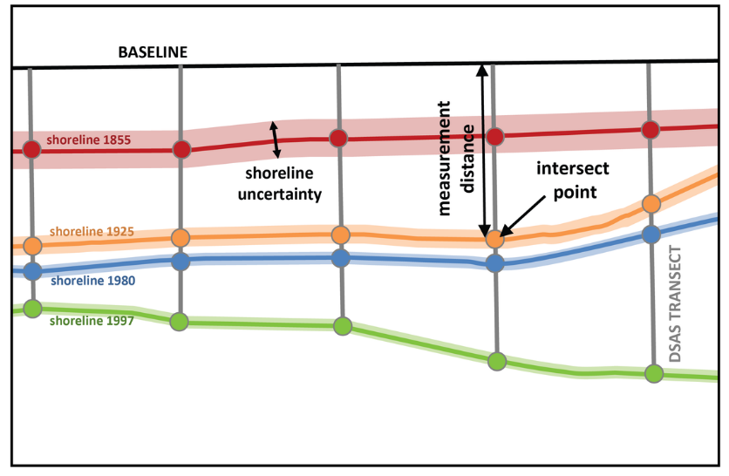

Figure 3-4. Example of DSAS transect casting (<https://www.usgs.gov/centers/whcmsc/science/digital-shoreline-analysis-system-dsas?qt-science_center_objects=0#qt-science_center_objects>)

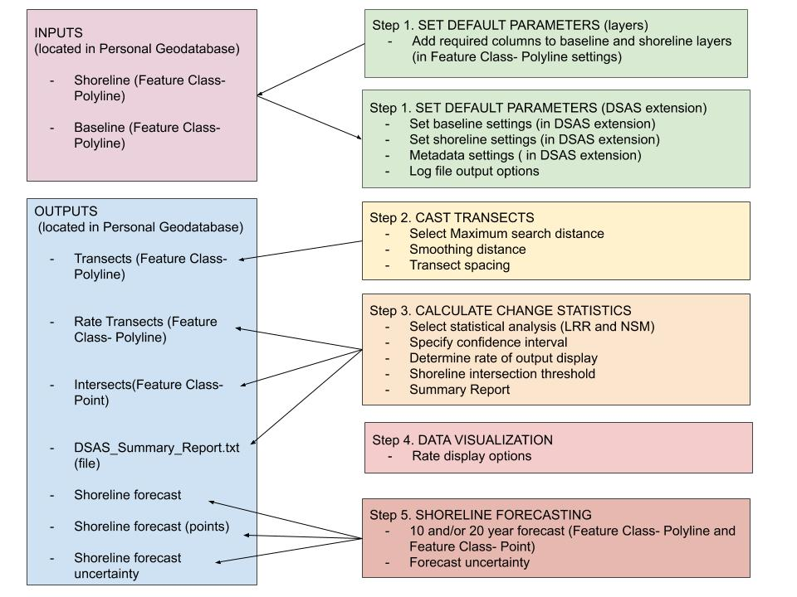

Figure 3-5. DSAS components and operational workflow (“Digital Shoreline Analysis System (DSAS) Version 5.0 User Guide.”, 2021).

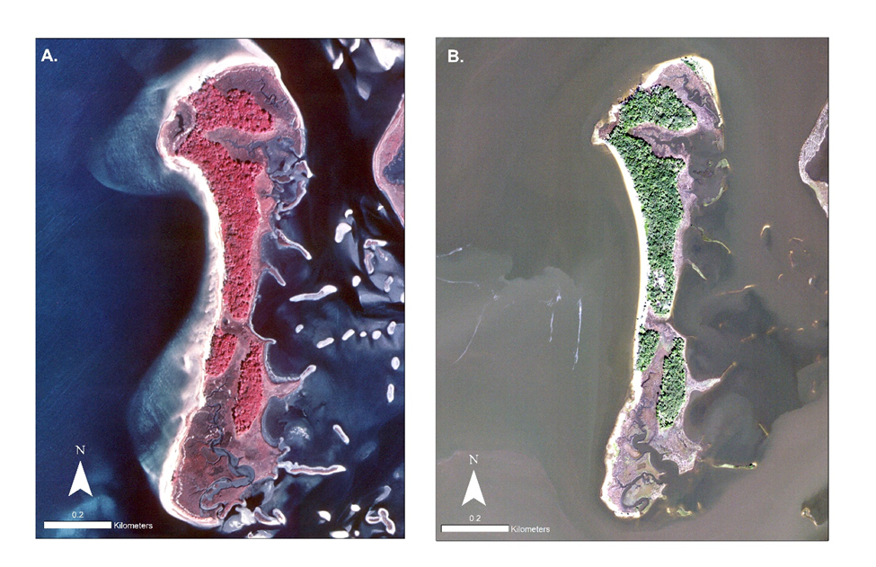

Figure 3-6. Observing the NAIP aerial photographs, in the same scale (1:3,000) and the same projection (NAD 1983 UTM, Zone 17N). A) consists of the 1994 aerial imagery and was taken on a day with a max wind speed of 19.31 KPH and a median river discharge of 274.9 (m^3/s) (Table 3-1). B) consists of the 2019 aerial imagery aerial imagery and was taken on a day with a max wind speed of 11.27 KPH and a median river discharge of 146.9 (m^3/s) (Table 3-1).

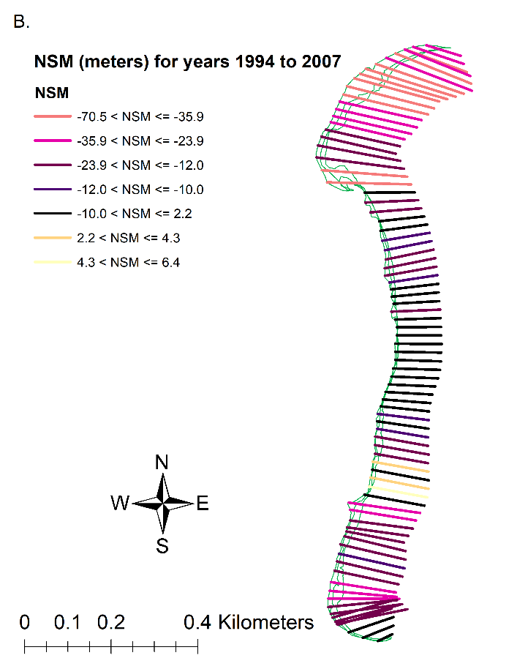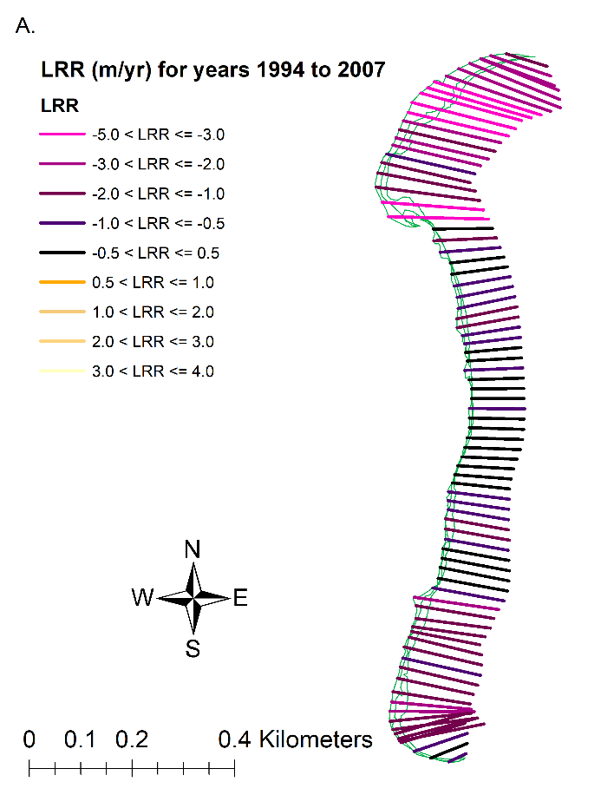

Figure 3-7. Results of DSAS calculations for years 1994 to 2007. A) Linear Regression Rates model (in m/yr) displaying transects which colors correspond to Figure 3-7, A. The transects (n= 82) display where along the shoreline erosion and accretion has been detected. B) Net Shoreline model (in meters) displaying transects which colors correspond to Figure 3-7, B. The transects display where along the shoreline erosion and accretion has been detected. The shorelines (green) include digitized shorelines for the years 1994 to 2007 in this figure.

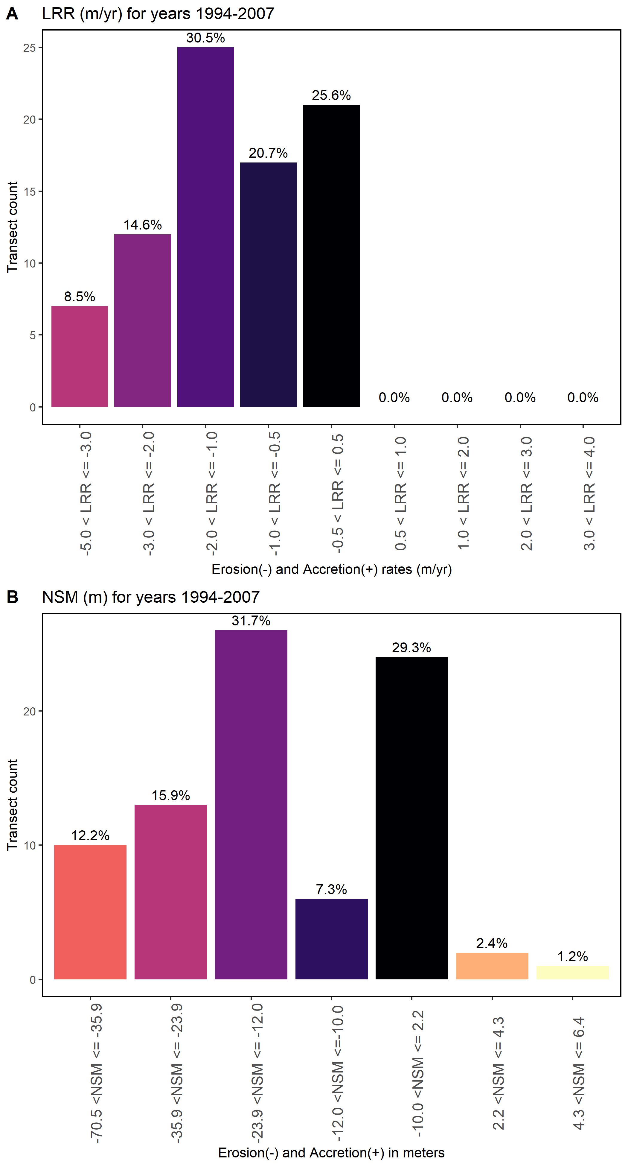

Figure 3-8. Figure of the DSAS statistics for years 1994 to 2007, A) LRR results for the transects counted of each of the bins calculated for erosion and accretion in meters, the negative x-values are erosion in meters, and the positive x-values are accretion, B) NSM results for the transects counted of each of the bins calculated for erosion and accretion in meters, the negative x-values are erosion in meters and the positive x-values are accretion. The total amount of transects calculated by DSAS is 82.

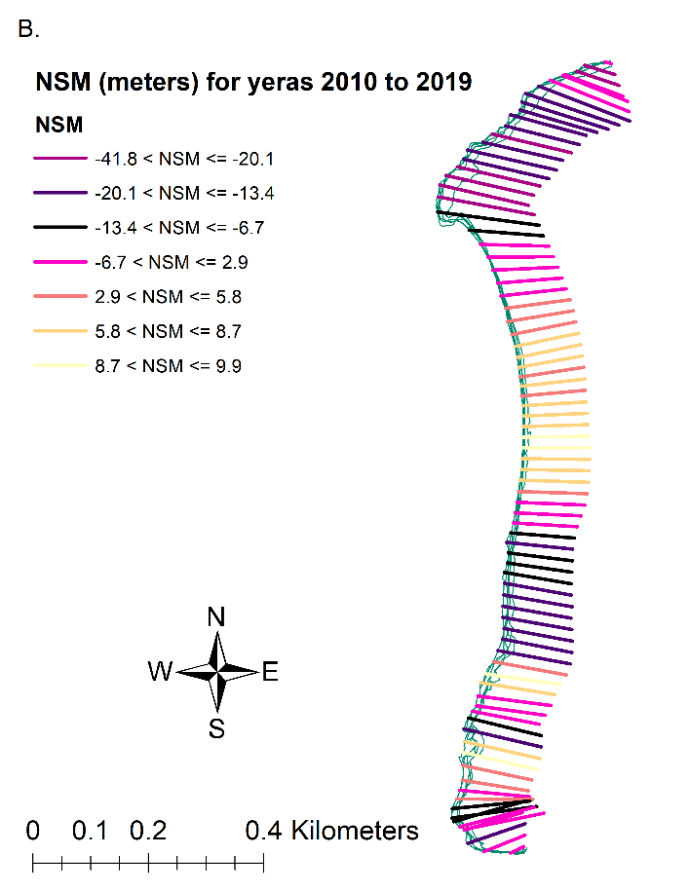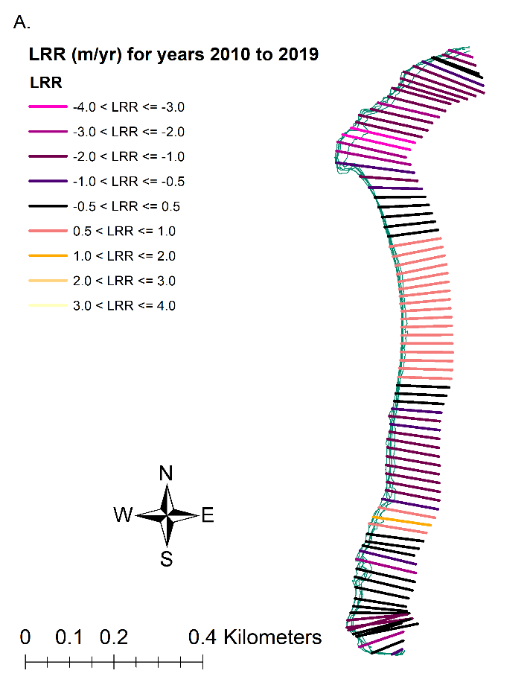

Figure 3-9. Results of DSAS calculations for years 2010 to 2019. A) Linear Regression Rates model (in m/yr) displaying transects which colors correspond to Figure 3-9, A. The transects (n= 82) display where along with the shoreline, erosion and accretion have been detected. B) Net Shoreline model (in meters) displaying transects which colors correspond to Figure 3-9, B. The transects display where along the shoreline erosion and accretion has been detected. The shorelines (green) include digitized shorelines for the years 2010 to 2019 in this figure.

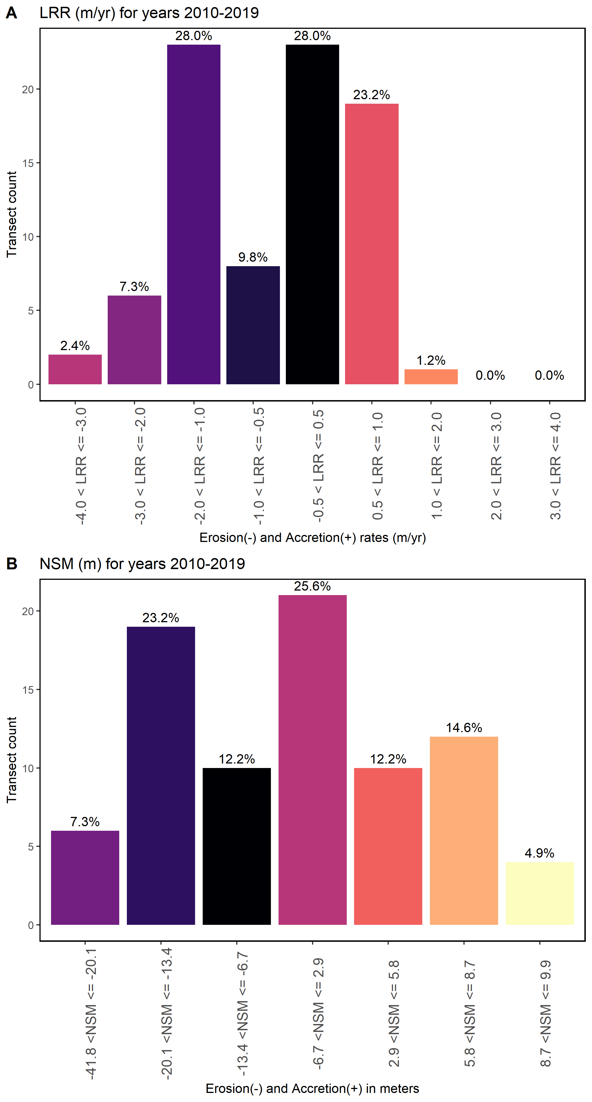

Figure 3-10. Figure of the DSAS statistics for years 2010 to 2019, A) LRR results for the transects counted of each of the bins calculated for erosion and accretion in meters, the negative x-values are erosion in meters and the positive x-values are accretion, B) NSM results for the transects counted of each of the bins calculated for erosion and accretion in meters, the negative x-values are erosion in meters and the positive x-values are accretion. The total amount of transects calculated by DSAS is 82.

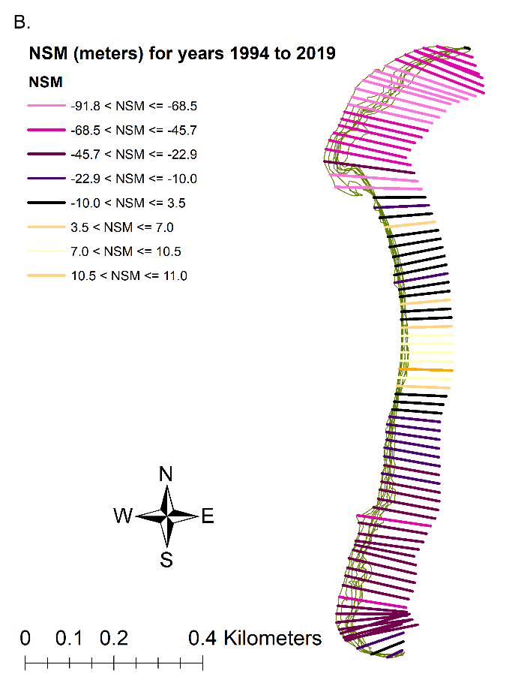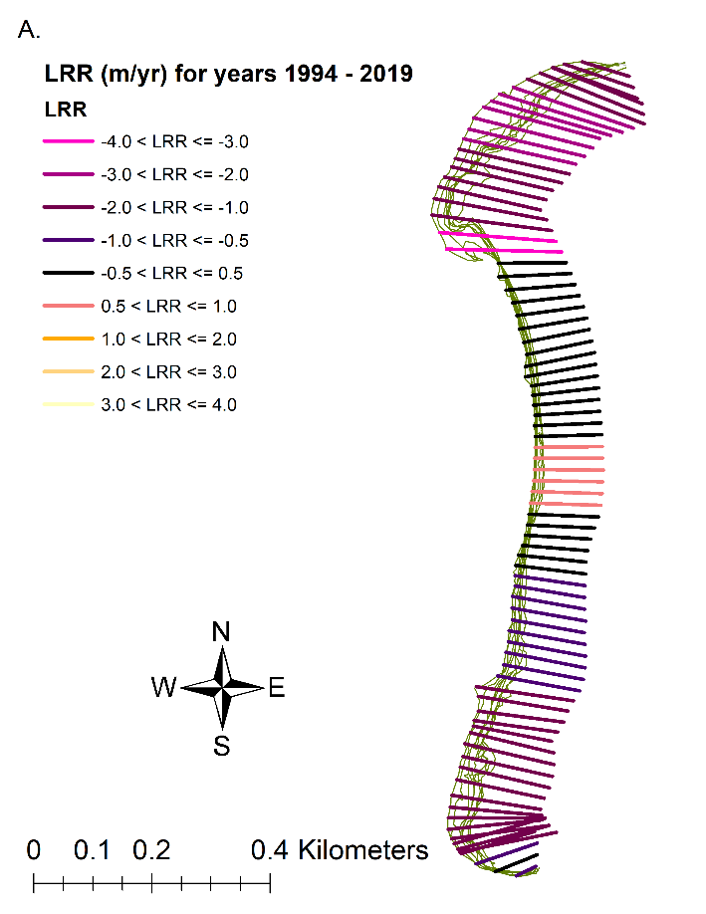

Figure 3-11. Results of DSAS calculations for years 1994 to 2019. A) Linear Regression Rates model (in m/yr) displaying transects which colors correspond to Figure 3-11, A. The transects (n= 82) display where along with the shoreline, erosion and accretion have been detected. B) Net Shoreline model (in meters) displaying transects which colors correspond to Figure 3-11, B. The transects display was along with the shoreline erosion, and accretion has been detected. The shorelines (green) include all digitized shorelines in this figure.

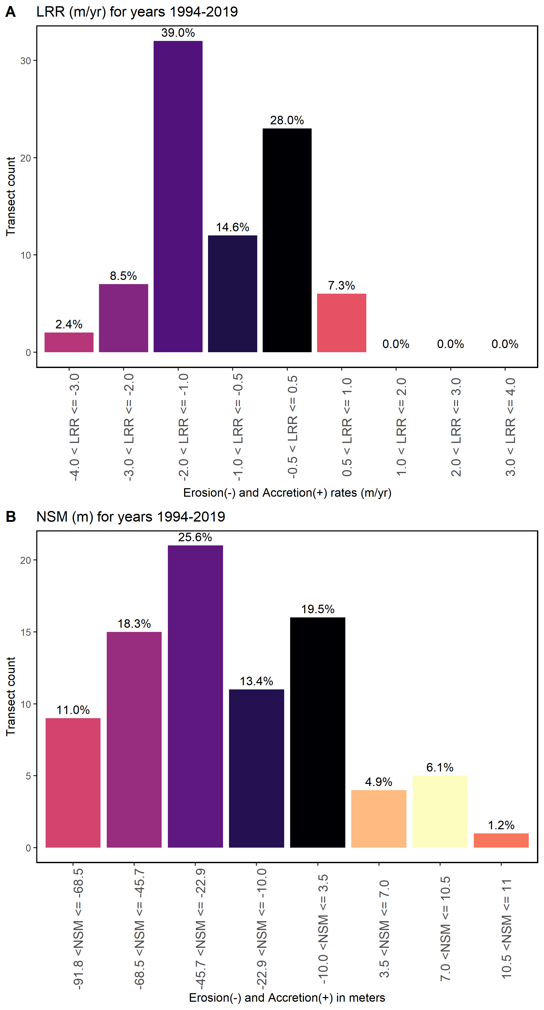

Figure 3-12. DSAS statistics for years 1994 to 2019, A) LRR results for the transects counted of each of the bins calculated for erosion and accretion in meters, the negative x-values are erosion in meters, and the positive x-values are accretion, B) NSM results for the transects counted of each of the bins calculated for erosion and accretion in meters, the negative x-values are erosion in meters and the positive x-values are accretion. The total amount of transects calculated by DSAS is 82.

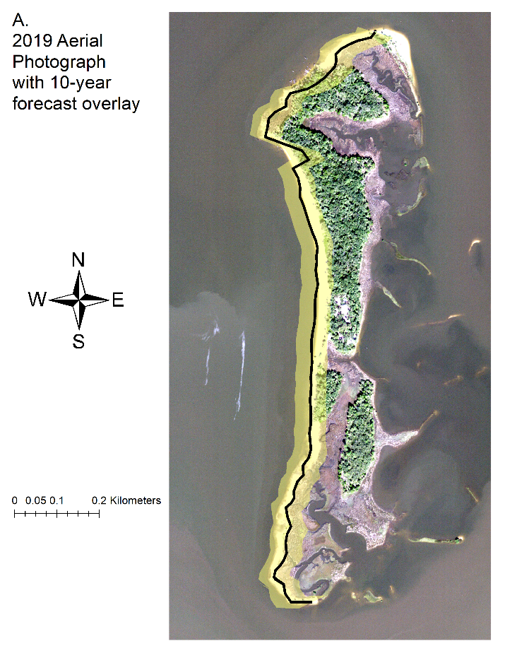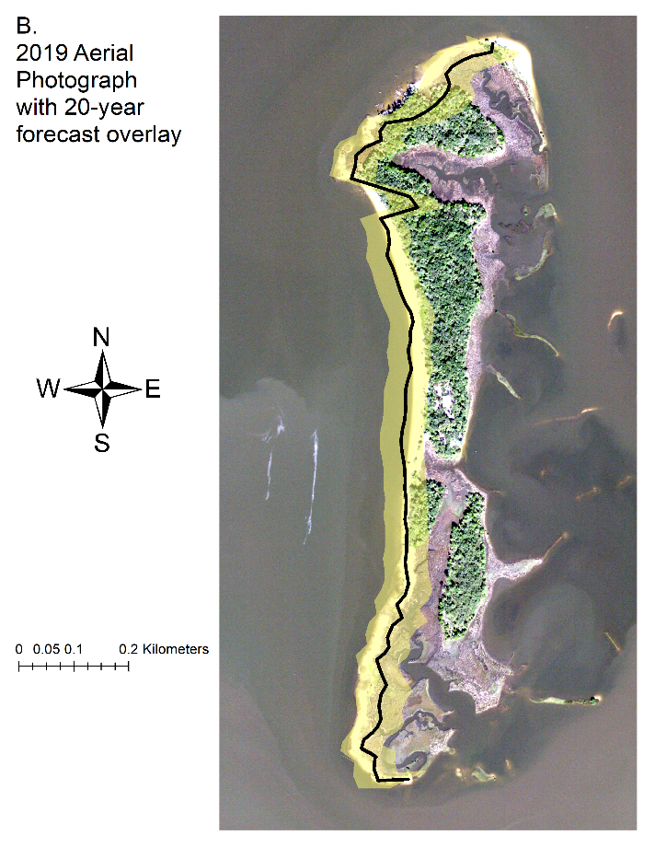

Figure 3-13. DSAS shoreline prediction forecast. A) Shoreline forecast for a 10-year prediction (thick black line) and its uncertainty (yellow shaded region) overlayed aerial imagery (2019) to display the predicted shoreline loss in comparison to the latest imagery selected. B) Shoreline forecast for a 20-year prediction (thick black line) and its uncertainty (yellow shaded region) overlayed aerial imagery (2019) to display the predicted shoreline loss in comparison to the latest imagery selected. Shorelines are located on the west side of each panel.

Table 3-1. Table of metadata for each aerial image used in this analysis including date, median river discharge, observed weather, and additional imagery metadata. River discharge information is calculated by data from <https://tidesandcurrents.noaa.gov/> at Cedar Key, Florida Station 8727520, and observed weather provided by [www.wunderground.com](http://www.wunderground.com). Imagery metadata are provided by USGS Earth Explorer, <https://earthexplorer.usgs.gov/>.

|  |  |  |  |
| --- | --- | --- | --- |
| Date | Median River Discharge (m^3/s)  Station ID= 02323500 | Observed weather | Metadata (USGS Earth Explorer) |
| January 20, 1994 | Value= 274.9 | Avg Temp (C)- 3.41 Precipitation (cm)- 0.00  Max Wind Speed (KPH)- 19.31 | Entity ID: DI00000000018672 (found in DOQ)  Map Projection UTM  Projection Zone 17N  Datum NAD83  Resolution 1.0  Units METER  Number of Bands 3  Sensor Type RGB |
| December 30, 1998 | Value= 180.37 | Avg Temp (C)- 9.30 Precipitation (cm)- 0.00  Max Wind Speed (KPH)- 25.75 | Entity ID: DI00000001164809 (found in DOQ)  Map Projection UTM  Projection Zone 17N  Datum NAD83  Resolution 1.0  Units METER  Number of Bands 3  Sensor Type RGB |
| November 02, 2007 | Value= 66.5 | Avg Temp (C)- 19.31  Precipitation (cm)- 0.00  Max Wind Speed (KPH)- 22.53 | Entity ID: N_2908356_NW_17_1_20071102 (found in NAIP)  Map Projection UTM  Projection Zone 17N  Datum NAD83  Resolution 1.0  Units METER  Number of Bands 3  Sensor Type CIR |
| September 19, 2010 | Value= 120.0 | Avg Temp (C)- 25.32 Precipitation (cm)- 0.00  Max Wind Speed (KPH)-24.14 | Entity ID: M_2908356_NW_17_1_20100919 (found in NAIP)  Map Projection UTM  Projection Zone 17N  Datum NAD83  Resolution 1.0  Units METER  Number of Bands 4  Sensor Type CNIR |

Table 3-1. Continued

|  |  |  |  |
| --- | --- | --- | --- |
| Date | Median River Discharge (m^3/s)  Station ID= 02323500 | Observed weather | Metadata (USGS Earth Explorer) |
| October 13, 2013 | Value= 232.2 | Avg Temp (C)- 22.13 Precipitation (cm)- 0.00  Max Wind Speed (MPH)- 10 | Entity ID: M_2908356_NW_17_1_20131013 (found in NAIP)  Map Projection UTM  Projection Zone 17N  Datum NAD83  Resolution 1.0  Units METER  Number of Bands 4  Sensor Type CNIR |
| November 12, 2015 | Value= 171.9 | Avg Temp (C)- 19.27 Precipitation (cm)- 0.00  Max Wind Speed (KPH)- 16.09 | Entity ID: M_2908356_NW_17_1_20151112 (found in NAIP)  Map Projection UTM  Projection Zone 17N  Datum NAD83  Resolution 1.0  Units METER  Number of Bands 4  Sensor Type CNIR |
| October 26, 2017 | Value= 226.3 | Avg Temp (C)- 12.60 Precipitation (cm)- 0.00  Max Wind Speed (KPH)- 14.48 | Entity ID: M_2908356_NW_17_1_20171026 (found in NAIP)  Map Projection UTM  Projection Zone 17N  Datum NAD83  Resolution 1.0  Units METER  Number of Bands 4  Sensor Type CNIR |
| November 10, 2019 | Value = 146.9 | Avg Temp (C)- 14.12 Precipitation (cm)- 0.00  Max Wind Speed (KPH)- 11.27 | Entity ID: M_2908356_NW_17_060_20191110 (found in NAIP)  Map Projection UTM  Projection Zone 17N  Datum NAD83  Resolution 0.60  Units METER  Number of Bands 4  Sensor Type CNIR |

Table 3-2. National Agriculture Imagery Program (NAIP) aerial imagery band wavelength ranges in units (µm) (<https://www.fsa.usda.gov/Assets/USDA-FSA-Public/usdafiles/APFO/support-documents/pdfs/fourband_infosheet_2017.pdf>)

|  |  |  |
| --- | --- | --- |
| Sensor Type | Color and wavelength (µm) | Band and color channel to display true color |
| RGB | Blue 400–500  Green 500–600  Red 600–700 | 1 – Red channel  2 – Green channel  3 – Blue channel |
| CIR/ CNIR | Blue 400–500  Green 500–600  Red 600–700  Near-Infrared 800–900 | 1 – Red channel  2 – Green channel  3 – Blue channel  4 – Near Infrared (not shown on-screen display) |

Table 3-3. Summary statistics calculated by DSAS, Distance: NSM (Net Shoreline Movement)

|  |  |
| --- | --- |
| Summary Statistic | Value |
| Total number of transects (counts) | 82 |
| Average distance (meters) | -29.1 |
| Number of transects with negative distance (counts) | 67 |
| Percent of all transects that have a negative distance | 81.70% |
| Maximum negative distance (meters) | -91.71 |
| Maximum negative distance (transect ID #) | 12 |
| Average of all negative distances (meters) | -36.83 |
| Number of transects with a positive distance | 15 |
| Percent of all transects that have a positive distance | 18.29% |
| Maximum positive distance (meters) | 10.91 |
| Maximum positive distance (transect ID #) | 44 |

Table 3-4. Summary statistics calculated by DSAS, RATE: LRR (Linear Regression Rate)

|  |  |
| --- | --- |
| Summary Statistic | Value |
| Total number of transects (counts) | 82 |
| Average rate (m/yr) | -0.95 |
| Average of the confidence intervals associated with rates | 0.49 |
| Reduced n (number of independent transects) | 900.00% |
| Uncertainty of the average rate using reduced n | 0.17 |
| Average rate with reduced n uncertainty (m/yr) | -0.95 +/- 0.17 |
| Number of erosional transects (counts) | 63 |
| Percent of all transects that are erosional | 76.83% |
| Percent of all transects that have statistically significant erosion | 69.51% |
| Maximum value erosion (m/yr) | -3.32 |
| Maximum value erosion (transect ID #) | 22 |
| Average of all erosional rates (m/yr) | -1.33 |
| Number of accretional transects (counts) | 19 |
| Percent of all transects that are accretional | 23.17% |
| Percent of all transects that have statistically significant accretion | 10.98% |
| Maximum value accretion (m/yr) | 0.62 |
| Maximum value accretion (transect ID #) | 44 |
| Average of all accretional rates (m/yr) | 0.31 |